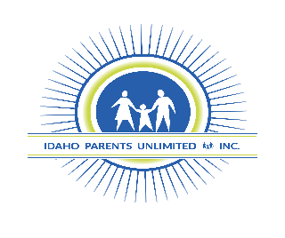

Photo/Video Release Form, 2022-2023

I, (print name)_________________________________(parent, legal guardian, or adult participant) grant permission to Idaho Parents Unlimited, Inc. their respective programs, directors, employees, agents (including but not limited to photographers, advertising agents, audio and video technicians and recorders), successors, assigns authorization to reproduce myself or my child’s physical likeness, voice and words, name, or artwork in video, television, radio, films, newspapers, magazines and social media.

_______________________________________________
Name of school or community Center

_______________________________________________
Name of Participant

________________________________________________
Signature of Parent / Guardian if under age 18

________________________________________________
Date

________________________________________________
*Description of student in photo(s)

Idaho Parents Unlimited Programs Include:
Statewide Parent Training and Information Center
Family to Family Health Information Center
Idaho Family Voices
IPUL Arts

